OS Concept: File System
By Rathod Raja V.

1. What is File ?
Ans:
1. Computers can store information on various storage media, such as magnetic disks, magnetic tapes, and optical disks. So that the computer system will be convenient to use, the operating system provides a uniform logical view of stored information. The operating system abstracts from the physical properties of its storage devices to define a logical storage unit, the file.
2. The file system consists of two distinct parts: a collection of files, each storing related data, and a directory structure, which organizes and provides information about all the files in the system.
3. File systems live on devices.
4. Files are mapped by the operating system onto physical devices.
5. A file is a named collection of related information that is recorded on secondary storage.
6. The information in a file is defined by its creator. It may be
a. Text File b. Source File c. Executable File
7. A text file is a sequence of characters organized into lines (and possibly pages)
8. A source file is a sequence of functions, each of\ which is further organized as declarations followed by executable statements.
9. An executable file is a series of code sections that the loader can bring into memory and execute.

2. What are various File Attributes ?
Ans:
1. A file is named, for the convenience of its human users, and is referred to by its name.
2. A file’s attributes vary from one operating system to another but typically consist of these:
• Name. The symbolic file name is the only information kept in human-readable form.
• Identifier. This unique tag, usually a number, identifies the file within the file system; it is the non-human-readable name for the file.
• Type. This information is needed for systems that support different types of files.
• Location. This information is a pointer to a device and to the location of the file on that device.
• Size. The current size of the file (in bytes, words, or blocks) and possibly the maximum allowed size are included in this attribute.
• Protection. Access-control information determines who can do reading, writing, executing, and so on.
• Time, date, and user identification. This information may be kept for creation, last modification, and last use. These data can be useful for protection, security, and usage monitoring.

3. What are various File Operations ?
Ans:
1. A file is an abstract data type.
2. The operating system can provide system calls to create, write, read, reposition, delete, and truncate files. Basic file operation are:
• Creating a file
• Writing a file
• Reading a file
• Repositioning within a file
• Deleting a file
• Truncating a file

4. What are common File types ?
Ans:
The common file types are:
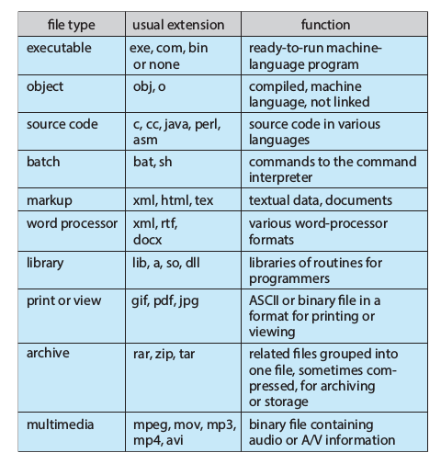

5. What are various File Access method ? Explain in brief .
Ans:
1. Files store information. When it is used, this information must be accessed and read into computer memory.
- Sequential Access
- Direct Access

Sequential Access:The simplest access method is sequential access.nformation in the file is processed in order, one record after the other. This mode of access is by far the most common; for example, editors and compilers usually access files in this fashion.

Direct Access: It is also called as a relative access.Here, a file is made up of fixed-length logical records that allow programs to read and write records rapidly in no particular order. The direct-access method is based on a disk model of a file, since disks allow random access to any file block. For Direct access, the file is viewed as a numbered sequence of blocks or records. Thus, we may read block 14, then read block 53, and then write block 7. There are no restrictions on the order of reading or writing for a direct-access file.Direct-access files are of great use for immediate access to large amounts of information. Databases are often of this type. When a query concerning a particular subject arrives, we compute which block contains the answer and then read that block directly to provide the desired information.

6. What is File System Mounting ? Explain in brief.
Ans:
1. Just as a file must be opened before it is used, a file system must be mounted before it can be available to processes on the system. More specifically, the directory structure may be built out of multiple volumes, which must be mounted to make them available within the file-system name space.
2. The mount procedure is straightforward. The operating system is given the name of the device and the mount point—the location within the file structure where the file system is to be attached.
3. Typically, a mount point is an empty directory. For instance, on a UNIX system, a file system containing a user’s home directories might be mounted as /home ; then, to access the directory structure within that file system, we could precede the directory names with /home , as in /home/jane .
4. Mounting that file system under /users would result in the path name /users/jane , which we could use to reach the same directory.

7. What is File Protection ? Explain in brief .
Ans:
1. When information is stored in a computer system, we want to keep it safe from physical damage (the issue of reliability) and improper access (the issue of protection).
2. Reliability is generally provided by duplicate copies of files.
3. Bugs in the file-system software can also cause file contents to be lost.
4. Protection mechanisms provide controlled access by limiting the types of file access that can be made. Access is permitted or denied depending on several factors, one of which is the type of access requested.
5. Access control:
• Owner. The user who created the file is the owner.
• Group. A set of users who are sharing the file and need similar access is a group, or work group.
• Universe. All other users in the system constitute the universe.

8. What is File System ? Draw File System Structure.
Ans:
1. A file system is an organized collection of regular files and directories. A file system
is created using the mkfs command.
2. One of the strengths of Linux is that it supports a wide variety of file systems, including the following:
- Traditional ext2 file system
- Various native UNIX file systems such as the Minix, System V, and BSD file systems
- Microsoft’s FAT, FAT32, and NTFS file systems
- ISO 9660 CD-ROM file system;
- Range of journaling file systems, including ext3, ext4, Reiserfs, JFS, XFS, and Btrfs

File System Structure:

1. The basic unit for allocating space in a file system is a logical block, which is some multiple of contiguous physical blocks on the disk device on which the file system resides.
2. For example, the logical block size on ext2 is 1024, 2048, or 4096 bytes.

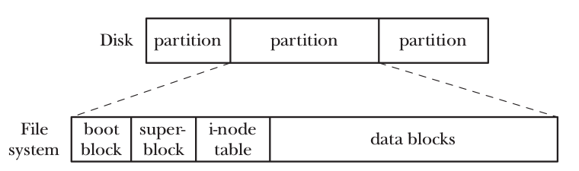
As show in above diagram hows the relationship between disk partitions and file systems, and
shows the parts of a (generic) file system.

9. What is Boot Block, Super Block, i-Node Table and Data Block.
Ans:
Boot Block:
This is always the first block in a file system. The boot block is not used by the file system; rather, it contains information used to boot the operat- ing system. Although only one boot block is needed by the operating system, all file systems have a boot block (most of which are unused).

Super Block:
This is a single block, immediately following the boot block, which contains parameter information about the file system, including:
- size of the i-node table;
- size of logical blocks in this file system
- size of the file system in logical blocks
Different file systems residing on the same physical device can be of different types and sizes, and have different parameter settings (e.g., block size). This is one of the reasons for splitting a disk into multiple partitions.

I-Node Table:
1. Each file or directory in the file system has a unique entry in the i-node table. This entry records various information about the file. I-nodes are dis- cussed in greater detail in the next section. The i-node table is sometimes also called the i-list.
2. A file system’s i-node table contains one i-node (short for index node) for each file residing in the file system.
3. I-nodes are identified numerically by their sequential location in the i-node table.
4. The i-node number (or simply i-number) of a file is the first field displayed by the ls –li command.
5. The information maintained in an i-node includes:
- File type (e.g., regular file, directory, symbolic link, character device).
- Owner (also referred to as the user ID or UID) for the file.
- Group (also referred to as the group ID or GID) for the file.
- Access permissions for three categories of user: owner (sometimes referred as user), group, and other
- Three timestamps: time of last access to the file (shown by ls –lu), time of last modification of the file (the default time shown by ls –l), and time of last status change (last change to i-node information, shown by ls –lc). As on other UNIX implementations, it is notable that most Linux file systems don’t record the creation time of a file.
- Number of hard links to the file
- Size of the file in bytes
- Number of blocks actually allocated to the file
- Pointers to the data blocks of the file.

Data Block:
The great majority of space in a file system is used for the blocks of data that form the files and directories residing in the file system.

10. What is Virtual File System ?
Ans:
1. Each of the file systems available on Linux differs in the details of its implementation. Such differences include, for example, the way in which the blocks of a file are allocated and the manner in which directories are organized. If every program that worked with files needed to understand the specific details of each file system, the task of writing programs that worked with all of the different file systems would be nearly impossible.
2. The virtual file system (VFS, sometimes also referred to as the virtual file switch) is a kernel feature create a abstraction layer for file system operation.
3. The VFS defines a generic interface for file-system operations. All programs that work with files specify their operations in terms of this generic interface.
4. Each file system provides an implementation for the VFS interface.
5. The VFS interface includes operations corresponding to all of the usual system calls for working with file systems and directories, such as open(), read(), write(), lseek(), close(), truncate(), stat(), mount(), umount(), mmap(), mkdir(), link(), unlink(), symlink(), and rename().

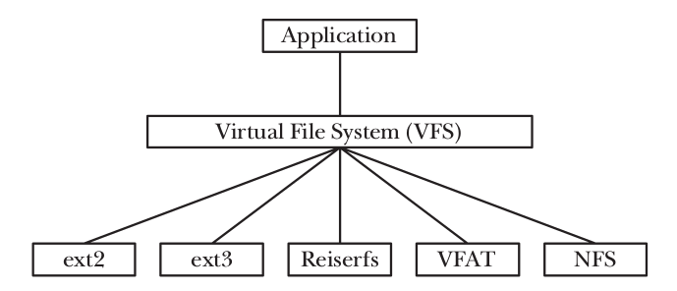

11. What is Mount Point ? Explain mounting and Unmounting File system ?
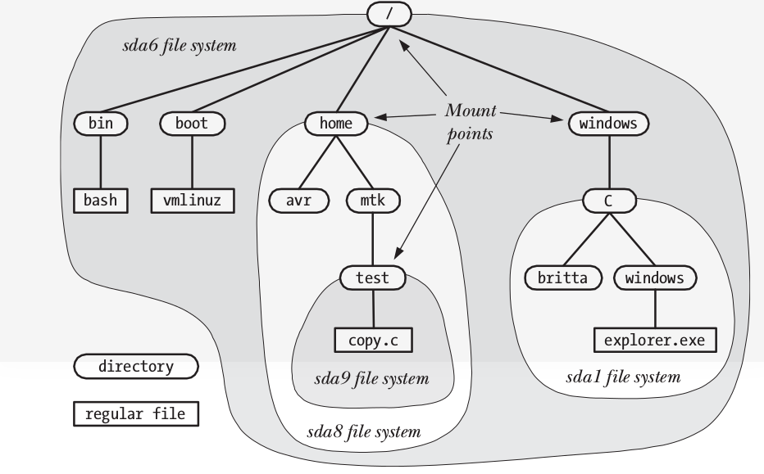
1. The mount() and umount() system calls allow a privileged ( CAP_SYS_ADMIN ) process to mount and unmount file systems.
2. A list of the currently mounted file systems can be read from the Linux-specific proc/mounts virtual file. /proc/mounts is an interface to kernel data structures, so it always contains accurate information about mounted file systems.
3. The mount(8) and umount(8) commands automatically maintain the file /etc/mtab , which contains information that is similar to that in /proc/mounts , but slightly more detailed. In particular, /etc/mtab includes file system–specific options given to mount(8), which are not shown in /proc/mounts . However, because the mount() and umount() system calls don’t update /etc/mtab , this file may be inaccurate if some application that mounts or unmounts devices fails to update it.
4. The /etc/fstab file, maintained manually by the system administrator, contains descriptions of all of the available file systems on a system, and is used by the mount(8), umount(8), and fsck(8) commands.

5. /etc/fstab file, maintained manually by the system administrator, contains descriptions of all of the available file systems on a system, and is used by the mount(8), umount(8), and fsck(8) commands.

6. The mount() system call mounts the file system contained on the device specified by source under the directory (the mount point) specified by target.

